­

BREAKING THE

LUCRARE DE ATESTAT

*COORDONATOR LUCRARE ANCA DIMCEA*

*COLEGIUL NAȚIONAL “GHEORGHE ȘINCAI”*

ENACHIOIU SORIN-CATALIN

ENIGMA

TABLE OF CONTENTS

Introduction …………………………………………………………………………………….. 4

Chapter 1: Alan Turing ……………………………………………………………………… 5

* 1. Biography ……………………………………………………… 5
  2. Contributions to science ……………………………….. 8
     1. ACE ………………………………………………. 8
     2. Entscheidungsproblem………………….. 9
     3. Turing Test …………………………………... 11
     4. Unorganized Machine ………………….. 13

Chapter 2: Bombe Machine ……………………………………………………………… 15

2.1 Enigma…………………………………………………………… 15

2.2 Bomba before the Bombe……………………………… 17

2.3 Bombe…………………………………………………………… 18

2.3.1 Bletchley Park …………………………….. 18

2.3.2 What was the Bombe? ................... 18

2.3.3 How the Bombe worked? .............. 19

2.3.4 Impact on World War II ………………. 21

Chapter 3: Did you know … ? ................................................................ 23

Conclusion ………………………………………………………………………………………. 26

Bibliography …………………………………………………………………………………… 27

*“Those who can imagine anything,*

*can create the impossible.”*

*-Alan Turing*

Introduction

*Have you ever thought that just the simple decryption of a code could save millions of lives?*

*Neither did I, untill one day when I saw the movie "The Imitation Game" with my family, a documentary about Alan Turing, the man that craftully engineered a machine able to find the correct Enigma's, a cipher used by Nazi Germany during the World War II ,setting of one day out of almost 159 quintillion possibilities in under 20 minutes. Not only did he play a crucial role in the second world war, but he also has lots of unbelieveble research.*

*These being said, we shall begin our journey by learning about one of the brightest minds of humanity , Alan Turing, and about the Bombe machine, that played a key role in the Allie’s win during The Second World War .*

Chapter 1

Alan Turing

1.1 Biography

Alan Turing was born at Paddington, London on 23 June 1912.

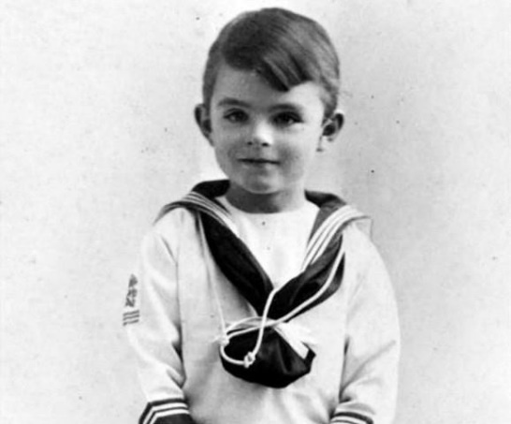Alan was the son of Julius Mathison Turing and Ethel Sara Stoney. Julius was a British member of the Indian Civil Service and he was often abroad and Sara was the daughter of the chief engineer of the Madras Railways.

Very early in life, Turing showed signs of the genius that he was later to display prominently. Alan was sent to St. Michael's school but the headmistress recognised his talent and so did many of his subsequent teachers. However, he did not seem to be obtaining any benefit and because of this was removed from the school after a few months.

Between January 1922 and 1926, Turing was educated at Hazelhurst Preparatory School where he seemed to be an 'average to good' pupil in most subjects. He became interested in chess while at this school and he also joined the debating society.

At the age of 13, he went on to Sherborne School. The first day of term coincided with the 1926 General Strike, in Britain, but Alan was so determined to attend that he cycled 60 miles to the school, although it was not a too demanding task for him , who later was to become a fine athlete.

He was criticised for his handwriting, struggled at English, and even in mathematics he was too interested with his own ideas to produce solutions to problems using the methods taught by his teachers. Despite producing unconventional answers, Turing did win almost every possible mathematics prize while at Sherborne.

Alan continued showing remarkable ability in the studies he loved, solving advanced problems in 1927, despite the fact that he have not even studied elementary calculus. One year later, he encountered Albert Einstein’s work, and not only did he grasp it, but it is believed that he also managed to deduce Einstein’s questioning of Newton’s laws of motion from a text in which this wasn’t explicitly said.

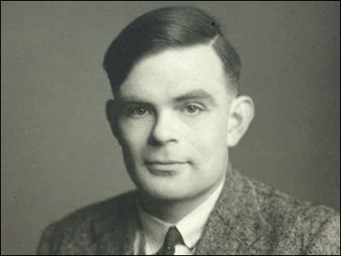

After Sherborne, Turing studied as an undergraduate from 1931 to 1934 at King's College, Cambridge where he was awarded first-class honours in mathematics, and in 1935 he was elected a fellow of the college.

In 1936 he published On Computable Numbers. It is in this paper that Alan introduced an abstract machine, now called a "Turing machine", which would be capable of performing any conceivable mathematical computation if it were representable as an algorithm.

Turing studied under Albert Einstein and was offered the post as personal assistant to Professor John von Neumann, the man behind the first American computer. However, after obtaining his PhD in June 1938, he returned to Cambridge University.

During the Second World War, Turing was a leading participant in the breaking of German ciphers at Bletchley Park. The historian and wartime codebreaker Asa Briggs has said, "*You needed exceptional talent, you needed genius at Bletchley and Turing's was that genius.*". At Bletchey, Alan concentrated on cryptanalysis of the Enigma cipher machine used by Nazi Germany.

After the war, Turing was invited by the National Physical Laboratory in London to work on the development of a large mainframe computer particularly, he worked on the structuring of the programme for the computer.

In 1950, the article Computing Machinery and Intelligence was published, in which Alan dealt with questions of artificial intelligence and developed what is today called the *Turing test*, that enables someone to decide whether is dealing with a human being or a machine.

On 8 June 1954, Turing's housekeeper found him dead at the age of 41, he had died the previous day. Cyanide poisoning was established as the cause of death.

1.2 Contributions to science

1.2.1 ACE (Automatic Computing Engine)

Alan Turing was recruited by the National Physical Laboratory (NPL) in London in order to create an electronic computer. His design for the Automatic Computing Engine (ACE) was the first complete specification of an electronic stored-program all-purpose digital computer.

He felt that speed and size of memory were crucial, and he proposed a high-speed memory of what would today be called 25 kilobytes, accessed at a speed of 1 MHz. He remarked that for the purposes required "*the memory needs to be very large indeed by comparison with standards which prevail in most valve and relay work, and it is necessary to look for some more economical form of storage*", and that memory "*appears to be the main limitation in the design of a calculator*.”.

Turing's report on the ACE was written in late 1945 and included detailed logical circuit diagrams and a cost estimate of £11,200.

Had Turing’s ACE been built as he planned, it would have had vastly more memory than any of the other early computers, as well as being faster. However, his colleagues at NPL thought the engineering was too difficult to attempt, and a much smaller machine was built in 1950, the Pilot Model ACE, which was one of the first computers built in the United Kingdom. It was built to a cut down version of Turing's full ACE design.

Even though the Pilot ACE is a smaller version of the design made by Alan, compared to the computers and phones we use nowadays, it was an enormous machine, as it can be seen in the following picture:

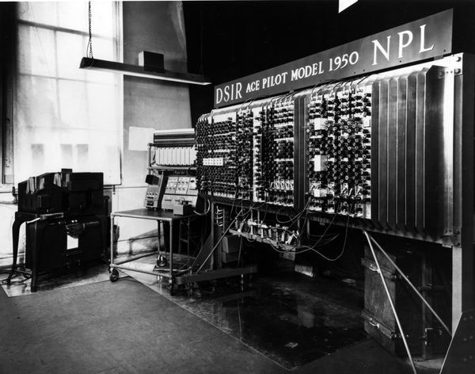

The NPL decided to push on and build the full machine, the ACE by 1957, unfortunately, it was obsolete even before completion, since much better techniques were by then available.

1.2.2 Entscheidungsproblem

In mathematics and computer science, the Entscheidungsproblem, which translated into English means the “*decision problem*” is a challenge posed by David Hilbert and Wilhelm Ackermann in 1928 and it sounded like this:

*“Is there an algorithm that takes, as input, a statement written in formal logic, and produces a “yes” or “no” answer that’s always accurate? “*

To be able to tackle down this question, Turing realized he needed a mathematical description of a machine that could solve algorithms. These machines came to be known as Turing machines.

A Turing machine is a hypothetical machine thought of by Alan in 1936. It consists of an infinite tape, as the memory, a tape head, a pointer to the currently inspected cell of memory, and a state transition table, to govern the behavior of the machine. Each cell of the tape can have one of a predetermined finite set of symbols, either a 1, a 0 or an empty space. The direction that the head moves, which values it erases, and which values it writes in, are dependent on a set of instructions provided to the machine. At the beginning, the input string is written on the tape, the tape head points to the first cell of the string, and all other cells are blank, as shown in the picture below:

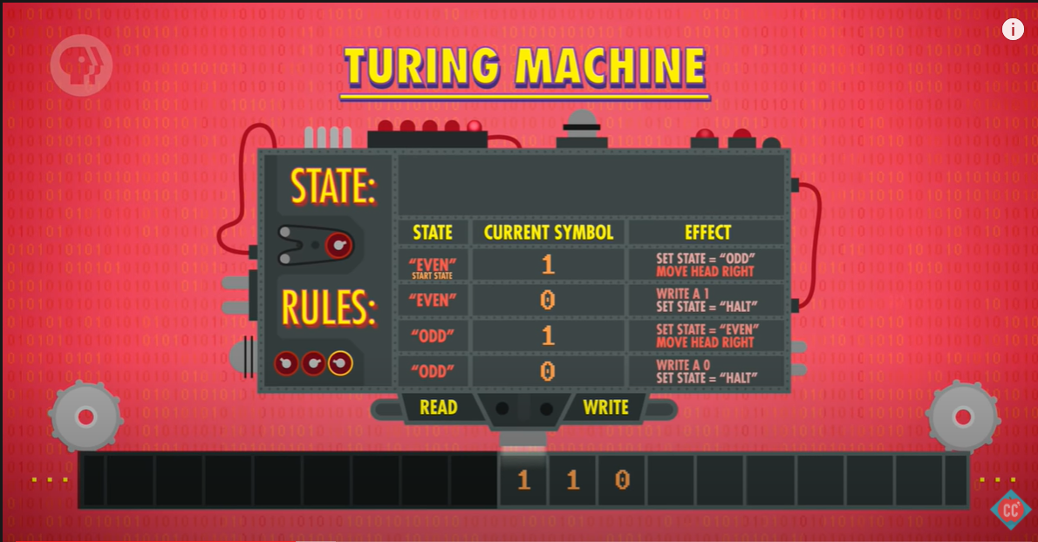

Despite its simplicity, the machine can simulate any computer algorithm, no matter how complicated it is, and therefore Alan Turing is often called the father of Computer Science.

To be able to respond to the decision problem Alan applied his new Turing Machine to an intriguing computational problem, the halting problem, which is the problem of determining, from a description of an arbitrary computer program and an input, whether the program will finish running, or continue to run forever. Turing proved in 1936 that a general algorithm to solve the halting problem for all possible program-input pairs cannot exist. It is one of the first cases of decision problems proven to be unsolvable. This proof is significant to practical computing efforts, defining a class of applications which no programming invention can possibly perform perfectly.

The impossibility of solving the halting problem also made Alan capable to publish a paper showing that a general solution to the Entscheidungsproblem is impossible, assuming that the intuitive notion of *"effectively calculable"* is captured by the functions computable by a Turing machine.

1.2.3 Turing Test

The Turing test, originally called *“The Imitation Game”*, by Alan Turing in 1950 is a test of a machine's ability to exhibit intelligent behavior equivalent to, or indistinguishable from, that of a human. In other words, it is a way of dealing with the question whether machines can think.

According to Alan, the question whether machines can think is itself *“too meaningless”* to deserve discussion. However, if we consider the more precise, and somehow related, question whether a digital computer can do well in a certain kind of game that Turing describes then, at least in Turing’s eyes, we do have a question that admits of precise discussion. Moreover, Turing himself thought that it would not be too long before we did have digital computers that could *“do well”* in the Imitation Game.

Turing proposed that a computer can be said to possess artificial intelligence if it can mimic human responses under specific conditions. The original Turing Test requires three terminals, each of which is physically separated from the other two. One terminal is operated by a computer, while the other two are operated by humans. The conversation would be limited to a text-only channel such as a computer keyboard and screen so the result would not depend on the machine's ability to render words as speech.

During the test, one of the humans functions as the questioner, while the second human and the computer function as respondents. The questioner interrogates the respondents within a specific subject area, using a specified format and context. After a preset length of time or number of questions, the questioner is then asked to decide which respondent was human and which was a computer.

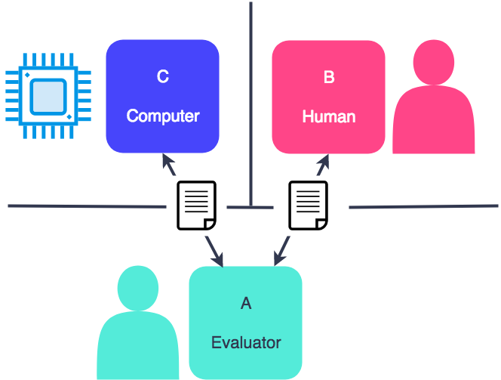

If the evaluator cannot reliably tell the machine from the human, the machine is said to have passed the test. The test results do not depend on the machine's ability to give correct answers to questions, only how closely its answers resemble those a human would give.

Since Alan first introduced his test it has become an important concept in the philosophy of artificial intelligence. The power and appeal of the Turing test derives from its simplicity. The philosophy of mind, psychology, and modern neuroscience have been unable to provide definitions of intelligence and thinking that are sufficiently precise and general to be applied to machines. Without such definitions, the central questions of the philosophy of artificial intelligence cannot be answered. The Turing test, even if imperfect, at least provides something that can be measured. As such, it is a pragmatic attempt to answer a difficult philosophical question.

A modification of the Turing test wherein the objective of one or more of the roles have been reversed between machines and humans is termed a reverse Turing test. An example of a reversed Turing test used nowadays is CAPTCHA. In order to be allowed to perform some action on a website sometimes it is required to pass a CAPTCHA test, in which the user is presented with alphanumerical characters in a distorted graphic image and asked to type them out. This is intended to prevent automated systems from being used to abuse the site.

1.2.4 Unorganized Machine

In a little-known paper entitled *“Intelligent Machinery”*, Turing had already investigated connectionist networks at the end of the forties. His employer at the National Physical Laboratory in London, Sir Charles Darwin, dismissed the manuscript as a *“schoolboy essay”*. Turing never

had great interest in publicizing his ideas, so the paper went unpublished until 1968, 14 years after his death. Copeland and Proudfoot, directors of the Turing Project1, a large ongoing project focused on Turing’s lifework at the University of Canterbury, revived Turing’s connectionist ideas in a Scientific American publication.

In describing networks of artificial neurons connected in a random manner, Turing had written the first manifesto of the field of artificial intelligence. Many of the concepts that became later important to AI were introduced in this work. One of the questions he was always interested in was whether it is possible for machinery to show intelligent behavior or not, as he stated at the beginning of his paper:

*“I propose to investigate the question as to whether it is possible for machinery to show intelligent behaviour. It is usually assumed without argument that it is not possible. Common catch phrases such as ‘acting like a machine’, ‘purely mechanical behaviour’ reveal this common attitude. It is not difficult to see why such an attitude should have arisen*.”

In the “*Intelligent Machinery*” report Alan suggested that the infant human cortex was what he called an "*unorganized machine*".

Turing defined the class of unorganized machines as largely random in their initial construction, but capable of being trained to perform tasks. Alan's unorganized machines were in fact the simplest possible model of the nervous system.

In his report Alan presented two examples of his unorganized machines. The first were A-type machines which essentially were randomly connected networks. The second were B-type machine that had a structure called a connection modifier, which allowed this type of machines to undergo *"appropriate interference, mimicking education"*.

Chapter 2

Bombe Machine

2.1 Enigma

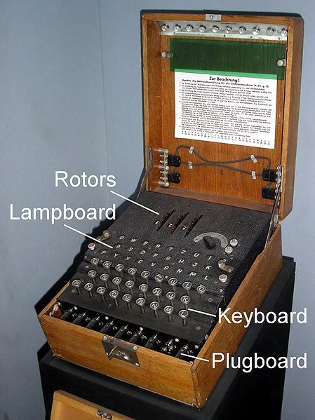The Enigma machine is a cipher device developed and used in the early-to mid-20th century to protect commercial, diplomatic, and military communication. It was employed extensively by Nazi Germany during World War II, in all branches of the German military. The Germans believed, erroneously, that use of the Enigma machine enabled them to communicate securely and thus enjoy a huge advantage in World War II. The Enigma machine was so secure that even the most top–secret messages were enciphered on its electrical circuits.

An Enigma machine is made up of several parts including a keyboard, a lamp board, rotors, and internal electronic circuitry. Some machines, such as the ones used by the military, have additional features such as a plugboard, as shown in the picture:

When a key on the keyboard is pressed, one or more rotors move to form a new rotor configuration which will encode one letter as another. Current flows through the machine and lights up one display lamp on the lamp board, which shows the output letter. So, if the "K" key is pressed,

and the Enigma machine encodes that letter as a "P," the "P" would light up on the lamp board.

The current flow when typing a letter would look like this:

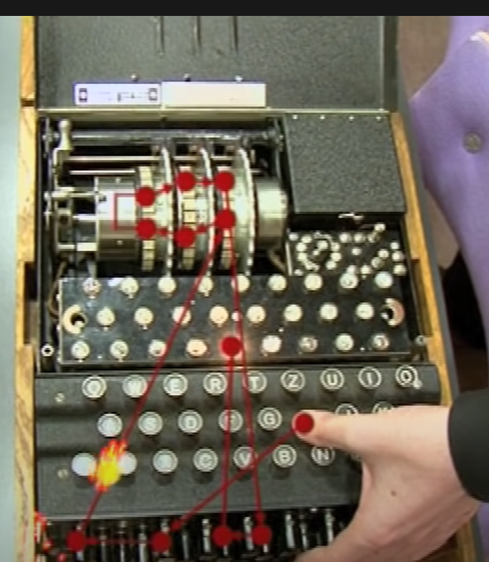

When users composed messages on Enigma machines, the devices’ rotors substituted new letters for each stroke in order to encrypt the message. Operators who received the encoded message would need an Enigma of their own, as well as the precise starting positions of the sender’s rotors, in order to be able to decode the message.

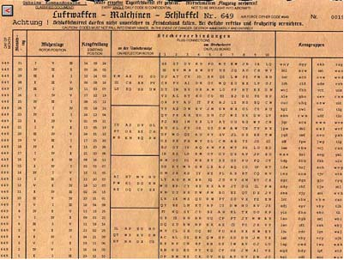Each month, Enigma operators received Key Sheets which specified which settings the machine would use each day. Every morning the configuration would change. One such Key Sheet looked as shown in the adjacent illustration:

2.2 Bomba before the Bombe

The earliest success against the German military Enigma was by the Polish Cipher Bureau. In the winter of 1932, Polish mathematician Marian Rejewski deduced the pattern of wiring inside the three rotating wheels of the Enigma machine.

After being able to infer the configuration of the wiring inside the three rotating wheels of Enigma, Rejewski invented a method that enabled him to find out, from each intercepted German transmission, the positions in which the wheels had started at the beginning of the message.

The Bomba was a special-purpose machine designed around October 1938 by Polish Cipher Bureau to break German Enigma-machine ciphers. The Cipher Bureau had started to build six machines of this kind and in mid-November 1938, they were ready, and the reconstructing of daily keys now took about two hours. Each Bomba machine essentially constituted an electrically powered aggregate of six Enigmas and took the place of almost one hundred workers.

The Poless kept their secret to themselves until July 1939 when, with the German invasion of their country imminent, they gave all their knowledge, as well as working replicas of the Enigma machine to the French and British.

In May 1940, however, a radical change to the Enigma system eliminated the flaw that Rejewski had exploited to discover the starting positions of the wheels.

2.3 Bombe

2.3.1 Bletchley Park

Bletchley Park is an English country house and estate in Milton Keynes. The mansion was constructed during the years following 1883 for the financier and politician Sir Herbert Leon in the Victorian Gothic, Tudor, and Dutch Baroque styles, on the site of older buildings of the same name.

During World War II, the estate housed the Government Code and Cypher School. Commander Alastair Denniston was operational head of GC&CS from 1919 to 1942. Denniston recognised, however, that the enemy's use of electromechanical cipher machines meant that formally trained mathematicians would also be needed Cambridge's Alan Turing and Gordon Welchman began training in 1938 and reported to Bletchley the day after war was declared, along with John Jeffreys, Oxford's Peter Twinn joined GC&CS in February 1939. Later-recruited cryptanalysts included the mathematicians Derek Taunt, Jack Good, Bill Tutte, and Max Newman, historian Harry Hinsley, and chess champions Hugh Alexander and Stuart Milner-Barry. Joan Clarke was one of the few women employed at Bletchley as a full-fledged cryptanalyst.

2.3.2 What was the Bombe?

At Bletchley Park, Alan Turing was asked to find a way to break Enigma messages. Because of changes to the German operating procedures and the introduction of extra wheels, the Polish Bomba was now obsolete.

Engima machines typically changed settings every 24 hours and with up to 159 quintillionpossible combinations every day, the staff at Bletchley

Park worked around the clock to break the settings by hand, but it was an impossible task. A mechanical method for identifying the keys was needed and Alan designed the Bombe to speed up the process.

Turing’s machine, which is a precursor to what we now think of as a computer, was able to rapidly speed up the rate at which intercepted messages were decoded, allowing Allied forces to react accordingly within hours rather than weeks.

2.3.3 How the Bombe worked?

Turing, inspired by the Poless, thought that in order to be able to decipher the encrypted messages sent with the Enigma Machines he would need to exploit flaws.

His methods were based around the assumption that each message contained a crib a known piece of German plaintext at a familiar point in the message. For example, the Atlantic weather forecast, which was written in the same format each day, was crucial. Location-detecting equipment in listening stations allowed codebreakers to find where a message was originating from and, if it matched up with the positioning of a weather station, it was likely that the word *“wettervorhersage”*, that means weather forecast, would be both present and in a similar place in every message.

Another clue was Enigma’s inability to code a letter as itself, for instance, an ‘S’ could never be an ‘S’. That way, the encrypted message could be lined up with the crib until no letter lined up as itself.

However, even with this information, there was not enough time or manpower to work through all the possible combinations. This was because individual letters were encrypted in a different way every time they were entered into the Enigma machine. Because of this Alan concluded that if you want to defeat a machine you need a machine.

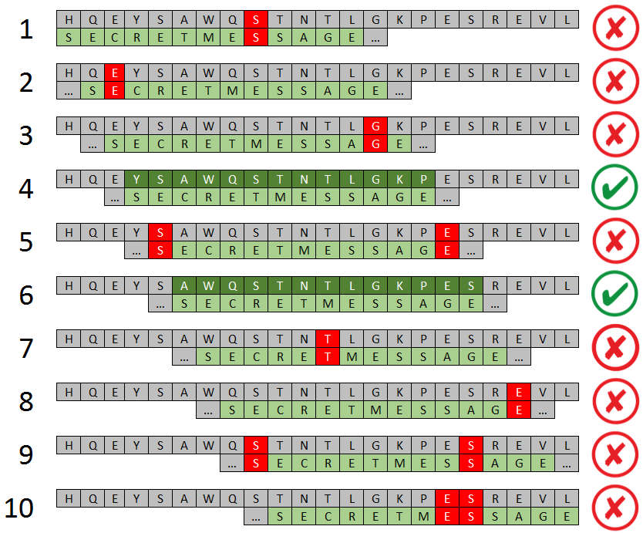An example of such a flaw is pictured in the image:

Bombe was an electromechanical machine comprised of the equivalent of 36 different Enigma machines, each one containing the exact internal wiring of the German counterpart. One such machine is illustrated below:

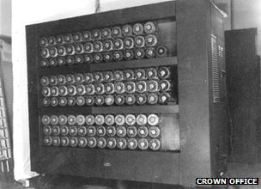

When the Bombe was switched on, each of the Enigmas is allocated a pair of letters from the obtained crib text, for example, when a D becomes a T in the guessed word.

Each of the three rotors moves at a rate mimicking the Enigma itself, checking on approximately 17.500 possible positions until it finds a match.

The machine only stops when each of the Enigma machines finds what it believes to be the correct pair of letters at the same time and opens its electrical circuit.

So rather than guessing the key, the Bombe used logic to dismiss certain possibilities. As Arthur Conan Doyle said: *“When you have excluded the impossible, whatever remains, however improbable, must be the truth.”*

This method, though successful, still provided several possible correct answers for the German ring settings, so further work needed to be done to find the right one. With the help of a checking machine, the process could be repeated until the correct Enigma configuration was discovered.

2.3.4 Impact on World War II

By speeding up the process of breaking the day’s Enigma settings, Turing’s invention meant staff were able to decode quickly and pass on information, often with enough time for it to be acted upon.

The use of Bombes helped the Allies to gather intelligence had a huge impact across many land, sea and air campaigns. Some historians estimate that Bletchley Park's massive codebreaking operation, shortened the war in Europe by as many as two to four years.

Intelligence uncovered prior to the battle of El Alamein in 1942 contributed to victory of the Allies in that Egyptian campaign, which proved to be a turning point of the war.

The German battleship Bismarck was located with the assistance of Enigma decrypts and sunk by air and surface attack in 1941.

If Turing and his group had not weakened the U-boats' hold on the North Atlantic, the 1944 Allied invasion of Europe, the D-Day landings, could have been delayed, perhaps by about a year or even longer, since the

North Atlantic was the route that ammunition, fuel, food and troops had to travel in order to reach Britain from America.

Harry Hinsley, a member of the small, tight-knit team that battled against Naval Enigma, and who later became the official historian of British intelligence, underlined the significance of the U-boat defeat.

Any delay in the timing of the invasion, even a delay of less than a year, would have put Hitler in a stronger position to withstand the Allied assault, Hinsley points out.

It took the Allied armies a year to fight their way from the French coast to Berlin, but in a scenario in which the invasion was delayed, giving Hitler more time to prepare his defenses, the struggle to reach Berlin might have taken twice as long.

Each year of the fighting in Europe brought on average about seven million deaths, so the significance of Turing's contribution can be roughly quantified in terms of the number of additional lives that might have been lost if he had not achieved what he did.

If U-boat Enigma had not been broken, and the war had continued for another two to three years, a further 14 to 21 million people might have been killed.

Chapter 3

Did you know …?

* *… Alan wore a gas mask while riding his bike to combat his allergies.*
* *… Turing learned exactly when to dismount to secure it in place before it slipped off, instead of fixing his bike’s faulty chain.*
* *… Alan almost became an Olympic athlete. He came in fifth place at a qualifying marathon for the 1948 Olympics with a 2 hour and 46 minute finish, 11 minutes slower than the 1948 Olympic marathon winner. However, a leg injury held back his athletic ambitions that year.*
* *… Alan Turing inspired by the chess champions he worked with at Bletchley Park, created in 1948, an algorithm for an early version of computer chess, it was the earliest known written computer game, a chess simulation called Turochamp, though it was never actually implemented on a computer as the code was too complicated to run on the machines of the time. Created with paper and pencil, the Turochamp program was designed to think two moves ahead, picking out the best moves possible. In 2012, Russian chess grandmaster Garry Kasparov played against Turing’s algorithm, beating it in 16 moves. “I would compare it to an early car, you might laugh at them, but it is still an incredible achievement" Kasparov said in a statement after the match-up.*
* *… in 2012, Monopoly came out with an Alan Turing edition to celebrate the centennial of his birth. Turing had enjoyed playing Monopoly during his life, and the Turing-themed Monopoly edition was designed based on a hand-drawn board created in 1950 by his friend William Newman. Instead of hotels and houses, it featured huts and blocks inspired by Bletchley Park, and included never-before-published photos of Turing.*
* *… Second World War codebreaker Alan Turing is the face of the new £50 note. The new note will feature a 1951 photo of Turing, a table and mathematical formulae from one of his most influential scientific papers. It will also feature a picture of the British Bombe code-breaking machine built at Bletchley Park, as well as a quote Turing gave in an interview on 11 June 1949: “This is only a foretaste of what is to come and only the shadow of what is going to be.”. One such note is pictured below:*

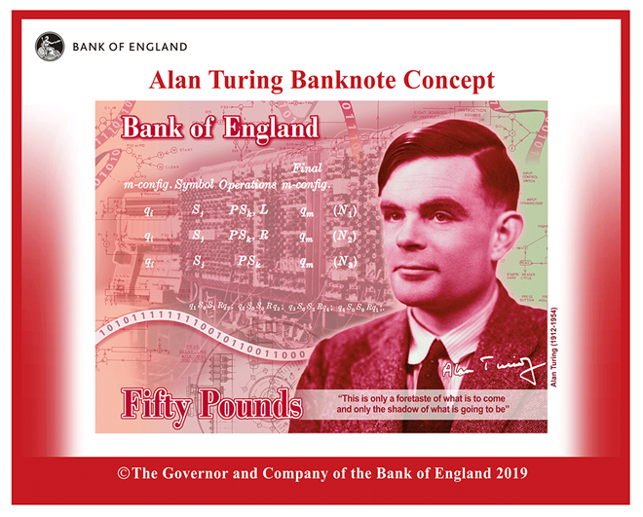

* *… in 2009, the prime minister Gordon Brown made an official apology for the “appalling way” Turing was treated, and in 2013 he was granted a posthumous pardon by the Queen.*
* *… there are no surviving original Bombe machines, but in the early 1990s retired engineer John Harper recruited a team to reconstruct a replica as a tribute to the wartime codebreakers. It was completed in 2007. Bletchley Park said the decision to house the replica at a new home was taken by the Rebuild Trust and had been "an amicable agreement with all parties". A joint statement from the Bletchley Park Trust and the Rebuild Trust said it was intended that the Bombe replica would originally be in Hut 11A at Bletchley Park, where the machines were housed during the war, but talks did not lead to a "mutually satisfactory agreement”. In the end, the National Museum of Computing has raised £60,000 in four weeks to house the replica of the World War Two codebreaking machine.*
* *… that the Government has announced details of the post-Brexit replacement of the Erasmus exchange program for UK students, which will cost more than £100 million after a controversial decision to withdraw from the scheme. Boris Johnson has promised the Erasmus student exchange program, which allowed participants to study across Europe, will be replaced by a “global” scheme named after Bletchley Park code breaker Alan Turing. The Department for Education said the Turing Scheme will provide funding for around 35,000 students to go on placements and exchanges globally from September 2021.*
* *…the ACM A. M. Turing Award is an annual prize given by the Association for Computing Machinery (ACM) for contributions "of lasting and major technical importance to the computer field" It is generally recognized as the highest distinction in computer science, or the "Nobel Prize of Computing". The award is named after Alan Turing.*

Conclusion

*In conclusion, Alan Turing was the founder of computer science, mathematician, philosopher, code breaker and a visionary*

*His genious embraced the first visions of modern computing and produces seminal insights into what became known as “artificial intelligence”.*

*Above all, Turing’s name is associated with the top-secret wartime operations of Britain’s code-breakers at Bleckley Park, where he oversaw and inspired the effort to decrypt cyphers generated by Nazi Germany’s Enigma machine, which had once seemed impenetrable. The Germans themselves regarded the codes as unbreakable.*

*With his pioneering work in computer science, Alan Turing is one of those rare people who can justifiably be said to have changed the way in which we live.*

Bibliography

* *https://en.wikipedia.org/wiki/Turing_machine*
* *https://www.britannica.com/biography/Alan-Turing*
* *https://www.britannica.com/technology/Automatic-Computing-Engine*
* *http://home.bt.com/tech-gadgets/crackinDsa*
* *https://www.youtube.com/watch?v=G2_Q9FoD-oQ&feature=emb_logog-the-enigma-code-how-turings-bombe-turned-the-tide-of-wwii-11363990654704a*
* *https://www.youtube.com/watch?v=V4V2bpZlqxa*
* *https://en.wikipedia.org/wiki/Bombea*
* *https://en.wikipedia.org/wiki/Bomba_(cryptography)a*
* *https://en.wikipedia.org/wiki/Universal_Turing_machinea*
* *https://en.wikipedia.org/wiki/Computing_Machinery_and_Intelligenceaa*
* *https://www.bbc.co.uk/programmes/profiles/5jQ6817N7QWTz5bJJspyDNy/alan-turing#:~:text=Alan%20Turing,-Fact%20title&text=Those%20who%20can%20imagine%20anything%2C%20can%20create%20the%20impossible*
* *https://www.youtube.com/watch?v=7TycxwFmdB0*
* *https://towardsdatascience.com/can-machines-think-using-the-turing-test-2dce3665b552*
* *https://www.cl.cam.ac.uk/projects/raspberrypi/tutorials/turing-machine/one.html*
* *https://brilliant.org/wiki/turing-machines/*
* *https://en.wikipedia.org/wiki/Entscheidungsproblem*
* *https://en.wikipedia.org/wiki/Halting_problem*
* *https://botsociety.io/blog/2018/03/the-turing-test/*
* *https://plato.stanford.edu/entries/turing-test/*
* *https://searchenterpriseai.techtarget.com/definition/Turing-test#:~:text=A%20Turing%20Test%20is%20a,cryptanalyst%2C%20mathematician%20and%20theoretical%20biologist.*
* *https://en.wikipedia.org/wiki/Turing_test*
* *https://www.britannica.com/biography/Alan-Turing#ref704283*
* *https://en.wikipedia.org/wiki/Automatic_Computing_Engine*
* *https://www.i-programmer.info/history/9-machines/11-an-ace-of-a-machine.html?start=1*
* *https://en.wikipedia.org/wiki/Pilot_ACE*
* *https://cds.cern.ch/record/263304/files/p230.pdf*
* *https://en.wikipedia.org/wiki/Unorganized_machine*
* *https://weightagnostic.github.io/papers/turing1948.pdf*
* *https://citeseerx.ist.psu.edu/viewdoc/download?doi=10.1.1.3.4044&rep=rep1&type=pdf*
* *http://www.alanturing.net/turing_archive/archive/l/l32/L32-005.html*
* *https://plus.maths.org/content/exploring-enigma*
* *https://brilliant.org/wiki/enigma-machine/#how-an-enigma-machine-works*
* *https://www.smithsonianmag.com/smart-news/divers-discover-rare-nazi-enigma-cipher-machine-wwii-180976469/*
* *https://en.wikipedia.org/wiki/Enigma_machine*
* *https://www.tandfonline.com/doi/abs/10.1080/02684528608431842?journalCode=fint20*
* *https://www.britannica.com/topic/Ultra-Allied-intelligence-project#ref1073436*
* *https://en.wikipedia.org/wiki/Bomba_(cryptography)*
* *https://en.wikipedia.org/wiki/Bletchley_Park*
* *https://www.tnmoc.org/bombe*
* *http://home.bt.com/tech-gadgets/cracking-the-enigma-code-how-turings-bombe-turned-the-tide-of-wwii-11363990654704*
* *https://bletchleypark.org.uk/whats-on/hut-11a-the-bombe-breakthrough*
* *https://www.101computing.net/enigma-crib-analysis/*
* *https://www.bbc.com/news/technology-18419691*
* *https://mathshistory.st-andrews.ac.uk/Biographies/Turing/*
* *https://www.facebook.com/AmbientNightProductions/posts/turingtuesday-alan-turing-was-born-in-maida-vale-london-on-june-23-1912-the-site/10156976225976393/*
* *https://spartacus-educational.com/Alan_Turing.htma*
* *https://mathshistory.st-andrews.ac.uk/Strick/Turing.pdfa*
* *https://www.independent.co.uk/news/business/news/alan-turing-new-50-pound-note-who-bank-england-release-date-a9005066.html*
* *https://www.mentalfloss.com/article/503325/15-riveting-facts-about-alan-turing*
* *https://www.bankofengland.co.uk/news/2019/july/50-pound-banknote-character-announcement*
* *https://www.bbc.com/news/uk-england-beds-bucks-herts-43402345*
* *https://inews.co.uk/news/education/turing-scheme-grants-overseas-study-erasmus-eu-brexit-808863*
* *https://www.computerhistory.org/revolution/birth-of-the-computer/4/96a*
* *https://en.wikipedia.org/wiki/Turing_Award*